TWO YEAR PROJECT TO INSTALL NEW BELLS AT VILLAGE CHURCH COMPLETE:
RINGING IN THE CHANGES
A two year project to install three additional new bells in a village church near Coalville has been completed.
The bell ringers at St. Peter’s Church, Thornton had their first ring of the new bells at the Christingle Service held on Christmas Eve.
Tower Captain Eric Roberts said, "with three existing bells already in the tower, the more traditional set of six bells sound much brighter as the key of the peal has been changed. Furthermore, the scope to ring a variety of methods is far greater and more enjoyable to listen too.”
"We have had so many lovely comments about how good they sound and the responses from villagers and the like showing keenness to learn "the art of campanology" has been most encouraging.”
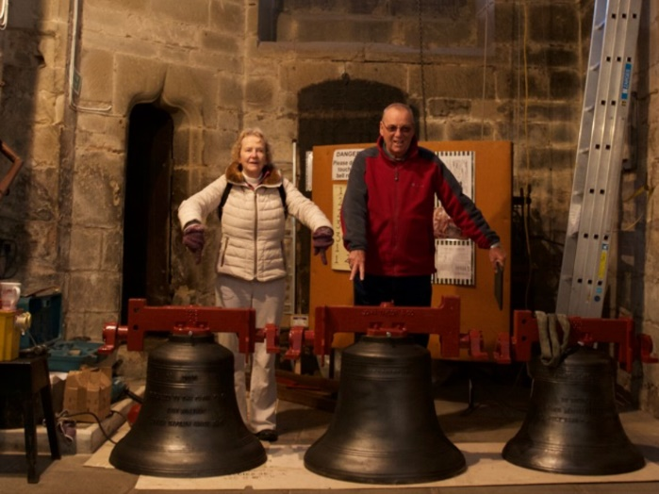
Two of the three bells were from redundant churches, one from Foxhills in Yorkshire, the other from a church in Lancaster. They were provided by Keltek Trust, a charity which specialises in relocating bells from redundant churches to active ones. These two bells were retuned at The John Taylor Bell Foundry in Loughborough to blend in with the existing three. Whilst this project was up and running a well-known local bellringer, John Jelley, sadly passed away and his estate left a substantial sum of money to the Keltek Trust. As a result of this gift, Keltek Trust kindly offered us a brand new treble which was cast at the Bell Foundry to complete our ring of six for which we are extremely grateful.
The bells were installed in November/December after funds exceeding £30,000 were raised from grants and donations from charities and a local appeal. (A list of such organisations is given below). In addition, a controlled sound proof system was installed at the same time giving the opportunity of reducing the sound during practice nights to accommodate the neighbours.
1. Hinckley & Bosworth Borough Council -Community Initiative Scheme
2. Leicester Diocesan Guild of Church Bell Ringers
3. The Jack Patston Charitable Trust
4. Barron Bell Trust
5. Sharpe Trust
6. Garfield Weston Trust
7. Leicestershire Historical Charitable Trust
8. All churches Trust Ltd
9. Friends of St. Peter’s
10 Local donations from the community

